The AI Dilemma: Exploring How Controlling Language in AI Policy Impacts Psychological Reactance and Conformity

Athena Filias
Florida International University

Abstract
Research suggests that both psychological reactance and conformity play roles in how people perceive and adhere to policies, but little is known about how they interact. The current studies examined the dynamics of reactance (study one and study two) and conformity (study two) in interpreting an AI policy. In study one, 120 predominantly undergraduate participants were randomly assigned to read a fictitious prospective policy regarding when AI usage is allowed and disallowed with high controlling language (HCL), low controlling language (LCL), or neutral controlling language (NCL) conditions in an in-person face-to-face study. In study two, the investigation was extended through an online Qualtrics survey, where 134 new predominantly undergraduate participants were introduced to a new condition of conformity (46% vs 86%) from former fictitious students along with the previous language condition (HCL vs LCL). In study one, participants viewed the AI policy as extreme and as a threat to freedom with greater levels of reactance-inducing language. Participants in study two found that the policy’s high-controlling language intensified perceptions of threat to freedom and intention to ignore AI policy, while agreement levels had minimal impact on these perceptions and intentions. However, an interaction effect between language control and agreement levels revealed that specific combinations of language control and agreement may elicit varied reactions, with intrinsic agreement potentially outweighing social influence in determining individuals' responses to AI policies. These results suggest that reactance is a significant determinant of policy opinion, while conformity to others is less influential unless combined under specific circumstances.
Keywords: psychological reactance, conformity, language, agreement, AI policy, freedom threat
The AI Dilemma: Exploring How Controlling Language in AI Policy Impacts Psychological Reactance and Conformity
Study One
In any modern society, rules must be imposed to maintain order and stability. But what happens when that produces the opposite effect? Why are signs such as “do not walk on grass” or “please clean up after your dog” are often accompanied by a treaded path or mountains of dog waste? The Psychological Theory of Reactance (PRT) seeks to explain this issue. Psychological reactance manifests itself when an individual’s freedom (real or imagined) becomes threatened with elimination, causing them to act in opposition to the restraint to reestablish the threatened freedom (Brehm & Brehm, 1981, as cited in Ma & Miller, 2022).
This Theory has been built upon and expanded through multiple avenues of research. What is most often seen in accordance with PRT is controlling language. Controlling language refers to the use of forceful language such as “must” or “required” as an attempt to control audiences into message conformity (Frey et al., 2021). The aim of testing these theories in experiments is to see how it may apply to real world scenarios and how society could use this information to improve the way laws or rules are implemented and subsequently followed.
The COVID-19 pandemic is one of the most widely noticed public display of reactance in accordance with vaccine reception in America. A study conducted by Ma and Miller (2022), sought to test the relationship between controlling language around vaccine mandates and reactance levels. The findings suggest that the higher the controlling language, the greater the perception of anger, freedom threat, and lower positive rating of the message. The inverse was also found in low controlling language which is consistent with previous findings. Although participants experienced negative reactions to the messages when the language was controlling, reactance was not reflected in vaccine intentions, suggesting that internal motivation might influence the strength that reactance is acted upon. This highlights the importance of word choice pertaining to government proposals and healthcare.
Reactance may be seen within the classroom setting as well. Frey et al. (2021) explored how controlling language affects reactance levels and intent to comply with syllabus rules. Participants were randomly assigned to read one of four syllabi with variations to fairness and controlling language (high/low controlling language, high/low fairness). In this context, fairness refers to the perceived equity and justice in rules, regulations, and practices implemented by instructors or educational institutions. Their results were recorded via questionnaires which measured their perceived threat to freedom, reactance, and intent to comply. The results concluded that reactance was highest when high controlling language was used with fair syllabi. High controlling language also induced high amounts of freedom threat and decreased intent to comply in students. Although this may be the case, high controlling language did not produce a significant level of reactance if the syllabus was unfair since the perceived threat was not elevated resulting in comparatively minimal levels of freedom restoration (Frey et al., 2021).
Similarly, Young-Jones et al. (2021) were interested in the inverse of the study conducted by Frey et al. (2021). Young-Jones et al. were interested in how autonomy-supportive language can influence students’ perceptions of a class, based on the amount of freedom or constraint the syllabus policy provides on student learning. With autonomy supportive language referring to satisfying all three basic psychological needs of autonomy, competence and relatedness are satisfied. Respectively, autonomy, competence, and relatedness represent the extent that individuals perceive control and accountability for their behavior, feel effective within their social environment to express their competencies, and seek positive integration into others' lives. The combination of which, results in achieving intrinsic motivation. Participants randomly selected one of two syllabi with either autonomy-supportive or controlling language and was given a questionnaire that measures their basic needs satisfaction, intrinsic motivation, learning climate, and intentions towards the class. The results showed that the more autonomy-supportive language there is, the higher the reported levels of autonomy, competence, and willingness to take the class compared to high controlling language which produces high levels of reactance. Echoing Ma and Miller (2022), intrinsic motivation was not affected by controlling or autonomy supportive language. Thus, showing that supporting individuals’ freedom is correlated with positive perceptions and willingness to complete the task.
It must be noted that reactance is not unique to individualistic societies. Quick and Kim (2009) conducted an experiment with controlling language and reactance on South Korean adolescents and compared that to the level of reactance experienced by Americans. Participants viewed a fictitious ad about a new camera with either controlling or non-controlling language. Questionnaires were used to measure their levels of perceived freedom threat, thoughts, anger, and reactance. Their findings were consistent with prior research; controlling language that produces freedom threatening behavior will result in anger and reactance to try to restore freedom. Although Koreans experienced reactance as Americans have, they had lower levels of reactance possibly due to their collectivistic culture placing less emphasis on individualism (Quick & Kim, 2009). Likewise, a study conducted by Rui et al. (2023) found a similar pattern. Participants who viewed anti-smoking ads with controlling language produced anger, reactance, and negative thoughts no matter their nationality (Chinese or American). Similar to the Koreans in the study conducted by Quick and Kim (2009), the level of reactance was lower in Chinese participants because of the difference in cultural collectivism. Moreover, Chinese individuals think of freedom as a privilege, not a right as Americans do. These two studies suggest that reactance is universally experienced no matter the nationality but differs in the perception of what constitutes freedom threat, resulting in lower levels of reactance in East Asian cultures (Rui et al., 2023).
As AI continues to expand at an exceptionally rapid rate, questions begin to arise on the proper way to govern it. Currently, few legal interventions are put into place to mitigate AI usage. This has led individual entities such as employers, institutions, and teachers to come up with their own regulations to mitigate its effects. In the educational setting, many students utilize AI such as ChatGPT to aid with schoolwork, writing, comprehension, and review which increases the ease of plagiarism. Like the aforementioned syllabus study conducted by Frey et al. (2021), our study’s main focus is on how participants view controlling language when it comes to AI usage, reactance level, and their intent to comply with such regulations.
We believe our study will be consistent with previous findings based on Psychological Reactance Theory. Henceforth, we have several predictions in this study. First, if participants read an AI policy that uses high controlling language, then they will more strongly agree that a) the policy gives them too little freedom to decide how to use AI, b) the policy threatens their freedom to choose how to complete assignments, and c) the policy is not respectful of their right to make their own decisions when compared to participants who read an AI policy with either low controlling or neutral language, which will not differ from each other. Second, if participants read an AI policy that uses high controlling language, then they will more strongly agree that a). the policy made them angry, b) the policy was too extreme, and c) the policy language was demanding when compared to participants who read an AI policy with either low controlling or neutral language, which will not differ from each other. Finally, if participants read an AI policy that uses high controlling language, then they will more strongly agree that a) they intend to use AI even in situations where the AI policy does not allow them to use it, b) they intend to ignore the AI policy, and c) they intend to use AI when they deem is appropriate when compared to participants who read an AI policy with either low controlling or neutral language, which will not differ from each other.
Methods Study One
Participants
There were 120 participants. Of these, 47 were male (39.2%) and 70 were female (58.3%), with 3 participants not providing their gender (2.5%). The age of the sample ranged from 17 to 88 (M = 24.09, SD = 9.19). This included 20% White (N =24), 50% Latino/a (N = 60), 2.5% Indigenous (N = 3), 15.8% Black (N = 19), 5.8% Asian (N = 7), and 5.8% MENA (N = 7). See Table 1.
Table 1
Demographics – Study One
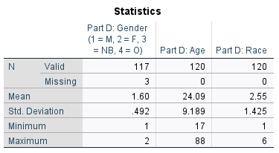
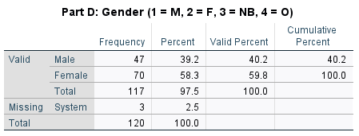
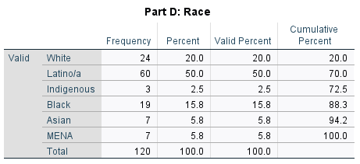
Materials and Procedures
One hundred twenty participants were surveyed to see their levels of psychological reactance (PR) based on one of three language conditions: neutral language, high controlling language, and low controlling language in AI policy. Before providing the questionnaire, which assessed their level of PR, informed consent was provided orally to ensure compliance with ethical guidelines. Then, participants read the instructions and completed the questionnaire. The questionnaire contained four sections: Part A which established the AI policy, Part B and C which measured the participant’s reactivity, and Part D which collected demographics information.
In Part A, all participants received identical basic information about an AI policy in all conditions, with the exception of language and tone used per study condition. Part A is the only part of the study that is varied across conditions via language choice (HCL v. LCL v. NL). The participants were given instructions to read a new AI policy that FIU was thinking of implementing that directly affects their student’s usage of AI such as ChatGPT. The policy is about a page long and explains why FIU believes that writing is an integral thinking skill. It details how AI like ChatGPT could interfere with that skill and how it is no substitution for a real-life person. It goes on to explain the resources and alternatives FIU offers for support with writing such as in the writing center. The final portion of Part A lists when AI can be used (i.e., grammar, brainstorming, outlining, and rephrasing), and when AI cannot be used (i.e., as a replacement for original papers, on assignments, if uncited, and if violating copyright). It concludes with possible academic sanctions that could result from violating academic integrity by the misuse of AI. For participants who received the neutral language condition, words such as “appropriate” and “allowed” would be used to convey the policy in a neutral tone. For participants who received the high controlling language condition, words such as “prohibited” and “must never use” would be used to convey the policy in a harsh tone. For participants who received the low controlling language condition, words such as “encouraged” and “should” would be used to convey the policy in a moderate tone. The aim is to see whether language choice would result in varying degrees of psychological reactance. In this study, it particularly focuses on whether reactance would be higher in high controlling language conditions as compared to low controlling or neutral language conditions.
After reading the AI policy in Part A, participants are then guided to Part B where they rated their thoughts and feelings about the proposed AI policy. From this point onwards, all surveys are identical. This rating was measured on an interval Likert scale ranging from 1 (Strongly Disagree) to 7 (Strongly Agree) for all ten statements. These statements included: (1) The AI policy gives me too little freedom to decide how I can use AI, (2) The AI policy provides helpful AI guidance, (3) The AI policy threatens my freedom to choose how I complete my assignments, (4) The AI policy is not respectful of my right to make my own decisions, (5) The AI policy impressed me, (6) The AI policy made me feel angry, (7) The AI policy made me feel valued, (8) The AI policy language is too extreme, (9) The AI policy language is demanding/bossy, and (10) The AI policy seems fair and reasonable. These statements followed three themes that focused on reactance, feelings, and controlling language. The theme of reactance was measured with statements one, three, and four. The theme of feelings was measured with statements six and seven. The theme of controlling language was measured with statements eight and nine. While statements two, five, and ten crossed multiple themes. Only two out of the ten statements were analyzed (“Threatens my freedom” and “Language too extreme”), whereas the rest were measured.
Following Part B, participants moved to Part C where they rated their likelihood (intention) to follow the proposed AI policy. This rating was measured on an interval Likert scale ranging from 1 (Strongly Disagree) to 7 (Strongly Agree) for four statements. These statements included: (1) I intend to use AI in situations where the AI policy allows me to use it, (2) I intend to use AI even in situations where the AI policy does not allow me to use it, (3) I intend to ignore the AI policy, and (4) I intend to use AI when I deem it appropriate. These statements were not be analyzed but rather used to assess likelihood of behavioral intentions of participants to use AI. These four statements, combined with the previous ten statements in Part B were the 14 dependent variables this study measured.
Once Part C has been completed, participants moved on to the final section of the experiment, Part D. This included five questions, one through four being standard demographic information such as: gender (Male, Female, Nonbinary, Other), age, race/ethnicity (White, Latino/a, Indigenous, Black, Asian, MENA, Other – explained), and if English was their first language (Yes, No – explained). Although these questions are unlikely to violate their privacy, the participants were allowed to leave any of the demographic questions blank if they did not wish to answer. Question five of this section included a multiple-choice attention check which prompted participants to mark the tone they remembered the AI policy using when describing the policy (Using AI is “prohibited”, “discouraged”, or “inappropriate”). The nominal measure of attention is important to note if the participant paid sufficient attention to the study, and if it had the desired effect (i.e., if participants in the high controlling language condition felt and recalled that the policy was controlling and so forth).
Following completion of the study, participants were thanked for their time and debriefed, noting the theory of psychological reactance, the hypotheses, controlling language, and their condition.
Results Study One
We ran a chi square with condition (High Controlling v. Low Controlling v. Neutral Language) as the independent variable and participant recall of a key word from the policy (“prohibited”, “discouraged”, or “inappropriate”) as the dependent variable. The chi square was significant, χ²(4) = 98.77, p < .001. Most “High Controlling” participants recalled the high controlling word “prohibited” (80%), most “Low Controlling” participants recalled the low controlling word “discouraged” (70%), and most “Neutral Language” participants recalled the neutral word “inappropriate” (75%). Cramer’s V, which is appropriate for this 3 X 3 test, was very strong. Participants thus saw our study manipulation as we intended. See Table 2 below.
Table 2
Crosstabs and Chi Square – Study One
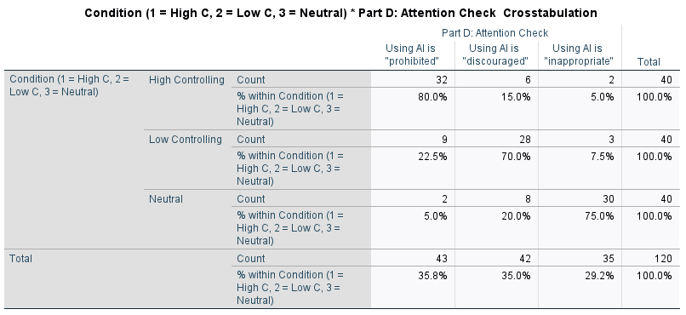
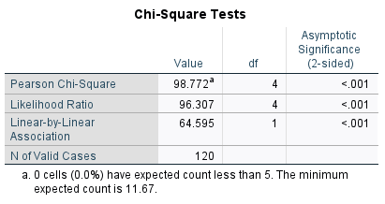
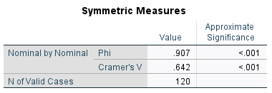
We ran a One-Way ANOVA with condition as our IV (High Controlling v. Low Controlling v. Neutral Language) and “Threatens my freedom” as our DV. It was significant, F(2, 114) = 8.93, p <.001. A Tukey post hoc test showed that participants more strongly agreed the policy threatened freedom in the High Controlling condition (M = 4.33, SD = 1.51) than in both the Low Controlling (M = 3.41, SD =0.99) and Neutral (M = 3.25, SD = 1.10) conditions, though Low Controlling and Neutral conditions did not differ from each other. See Table 3.
Table 3
ANOVA Freedom Threat – Study One
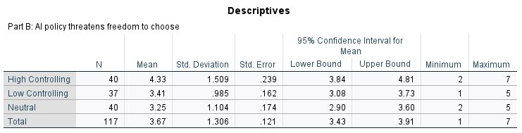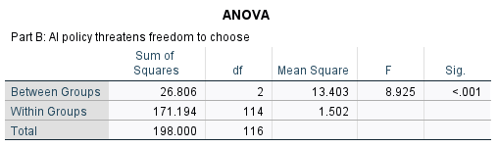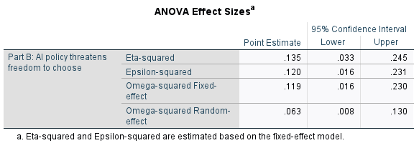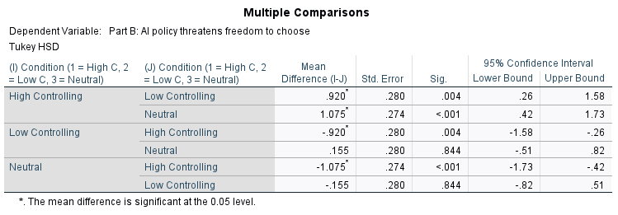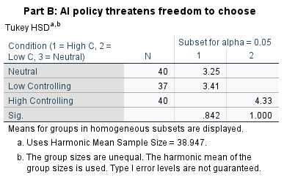
We ran a One-Way ANOVA with condition as our IV (High Controlling v. Low Controlling v. Neutral Language) and “Language too extreme” as our DV. It was significant, F(2, 117) = 8.43, p <.001. A Tukey post hoc test showed that participants more strongly agreed the policy was too extreme in the High Controlling condition (M = 4.18, SD = 1.24) than in both the Low Controlling (M = 3.33, SD =1.51) and Neutral (M = 3.45, SD = 0.90) conditions, though Low Controlling and Neutral conditions did not differ from each other. See Table 4.
Table 4
ANOVA Language is too Extreme – Study One
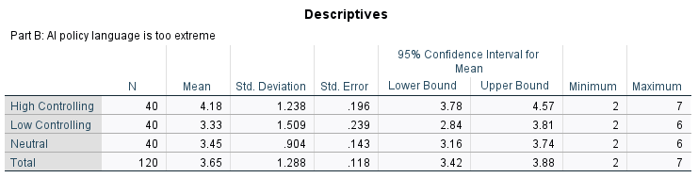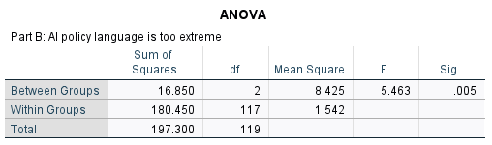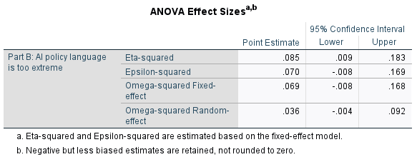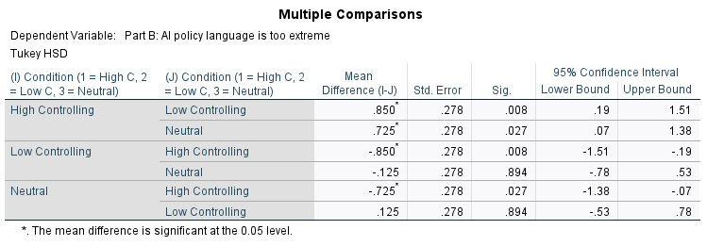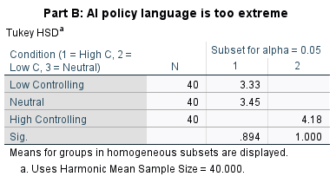
Discussion Study One
We hypothesized that if participants read an AI policy that uses high controlling language, then they will more strongly agree that the policy threatens their freedom to choose how they complete their assignments when compared to participants who read an AI policy with either low controlling or neutral language, which will not differ from each other. We also hypothesized that if participants read an AI policy that uses high controlling language, then they will more strongly agree that the policy was too extreme, when compared to participants who read an AI policy with either low controlling or neutral language, which will not differ from each other. Our results supported our hypotheses. Participants in the high controlling condition more strongly agreed with the statement that the policy threatens their freedom, and that the policy was too extreme than those in the low controlling or neutral condition. The low controlling and neutral language conditions did not differ in their ratings. If this study follows the same patterns as previous literature, participants may have perceived the specific key words in high controlling language as controlling. Subsequently, participants may perceive this language as a threat to freedom which would decrease their intent to comply in order to regain control and personal freedom. Put simply, the observed findings may be attributed to high controlling language inducing psychological reactance.
Study Two
In Western society, independence is encouraged and reflected in saying such as “the squeaky wheel gets the grease”. Many individuals, especially Americans, believe that to achieve true success and happiness, one must follow their own heart and carve their own path. But is that really the case? As inherently social beings, humans often gauge their circumstances by observing others. Without knowing it, people tend to conform to a group to gain an accurate perception of reality and to gain acceptance within a group. This is called Normative and Informational Influence, respectively. Normative influence is defined as fulfilling social expectations to be adopted within a group while Informational influence is defined as the act of looking to others for information as evidence of reality, based on the assumption that they possess accurate information (Pool & Schwegler, 2007). Both are integral components of conformity that shape individuals' behaviors and decisions in social contexts.
To explain conformity further, Song et al. (2012) preformed a comprehensive scientific summary that explores how both irrational and rational forms of conformity can contribute to understanding abidance, compliance, obedience and heard behavior and their real-world applications. Conformity is when an individual’s behavior or attitudes follows an internal (experience or instinct) or external (other individuals, groups, policies, organizations, etc.) objects. When conformity is irrational, the individual is guided or influenced by the object resulting in heard behavior (following the crowd) through an internal feeling. This behavior is often enacted to avoid punishment or maintain a favorable environment, such as complying with instructions to avoid abuse or retain employment. For example, individuals may conform to majority decisions due to misunderstandings (feeling that one’s own information is incorrect, and by proxy the majority’s information should be correct due to the high consensus) or fear of social repercussions (such as being looked down upon) by the majority.
In contrast, Song et al. (2012) discovered that when conformity is rational, it is guided by thinking judgement or reasoning and followed by abidance, obedience, and compliance to outside structures. Abidance occurs when the subjects seek to learn information from the object due to ambiguous circumstances, a behavior that follows informational influence on conformity. For example, citizens may accept laws for the perceived common good and protection. Obedience occurs when the subject is subordinate to the object to seek a reward or prevent punishment if they value the object highly enough (such as following government law to avoid imprisonment). Compliance, on the other hand, occurs after the subject has already judged and deduced their attitudes in relation to the object, typically to meet expectations of others and maintain social relationships. This can be seen in children who comply with their parents to show respect.
Through analyzation of various scientific papers, Song et al. (2012) noted that these forms of conformity are not mutually exclusive but can intertwine and transition between one another. By understanding why people conform, better inferences about how people will react to certain situations can be inferred. It may seek to explain why people conform, their reasons for doing so, and how it may benefit them. All forms of rational and irrational conformity can be observed when discussing rates of approval for prospective policies, allowing for each individual to exemplify one or multiple forms (such as abidance, obedience, and compliance) of conformity.
Echoing Song et al. (2012), researchers Pool and Schwegler (2007) reaffirmed the idea that multiple factors combine to contribute to individuals' reasons for choosing to conform. Pool and Schwegler (2007) conducted a study where individuals' motives to conform to social norms based on accuracy, self-related, and other-related factors were studied. Accuracy motives entails conforming to social norms out of a lack of information (informational influence) as individuals perceive it as the objectively correct thing to do, which is similar to abidance as mentioned by Song et al. (2012). This could include reading assigned material for a class, which complies with class guidelines, as it is perceived to be the most effective way to succeed in the class. For instance, an individual who participates in cleaning up their community complies with the norm of environmental activism since it aligns with their self-concept of being a conscientious person. Furthermore, self-related motives involve individuals conforming due to norms that align with their self-identity or group affiliation. Subsequently, other-related motives involve conforming to norms for the approval of others (normative influence), similar to compliance as previously mentioned. For example, teens comply with other peers through underage drinking to gain approval.
Pool and Schwegler (2007) tested these factors by dividing participants into two groups where one group’s attendance policy was affected grading, while the other group’s attendance did not affect grading at all. Questionnaires assessed participants' motives for conforming to class attendance norms, attitudes toward attendance, and intentions to attend class. The results concluded that situational factors are a large determinant of conformity to social norms. Accuracy and self-related motives predicted attendance intentions in the presence of an attendance policy, while attitudes and other-related motives predicted intentions in the absence of such a policy. Put differently, when the consequences are more valuable to the individual, more intensive reflection in determining the correct course of action and introspection of their self-concept is used in assessing conformity in a policy. Conversely, when the consequence to the individual is less valued, norms of others are used to assess policy conformity. These findings indicate that individuals may have multiple reasons to conform that can change over time in response to differing situational circumstances. Thus, if an individual reads a policy concerning AI usage which intends to induce conformity, direct threat and importance to the individual would be assessed to determine the probability of adherence.
Conformity has also been observed in varying degrees amongst differing age groups. Castrellon et al. (2023) conducted a study that investigates how social conformity effects middle-aged, older adults, and young adults compared to previous research which focused on predominantly young adult and adolescent populations. The results indicated that peer influence has the same effect across all age groups, contradicting the previous assumption that peer influence declines after adolescence. Understanding how susceptibility to social pressure changes over time, and how conformity influences age populations differently, underscores the importance of considering individual differences in the decision-making process when judgments based on social influence is needed.
Conformity and self-identification within a group has also been seen to impact decision making on policy. Toff and Suhay (2018) conducted an experiment where the influence of party elites (diplomats) and co-partisan peers (fellow citizens who share the same political ideology) were analyzed on the basis of conformity to policy topics of education and international trade. Participants completed a survey that measured political attitudes and were randomly assigned to different groups that presented information about two policy debates. The information was provided about how party elites or co-partisan peers from their political party voted on issues of educational policy or international trade. Subsequently, participants expressed their own views on the assigned policy issue though a questionnaire which was recorded and analyzed to determine the effects of elite and peer cues on policy preferences. The results indicated that both groups (elite and peer) had a significant influence on conformity to policy decisions. More notably, conformity to peer cues was found to be strongly influenced by the strength of participants' social identification with their group (party). This reveals that the role of social identity and group influence is important in conformity as it is a strong determinant of decision making. Thus, suggesting that individuals are more likely to conform when looking to others for guidance who are in the same group or similar background, possibly as a form of information gathering when knowledge is limited.
Conformity to opinions of group majority has also been seen to surpass one’s own preferences in favor of the collective. Researchers Prišuta et al. (2023) explored how the influence of social influence affects music liking, considering individual music taste, when group norms were present. The results displayed a significant effect on susceptibility to social influence to conform to a group norm despite own personal preference. Additionally, Participants adjusted their ratings based on the information provided This strengthens the notion that peer influence can shape individual preferences for many reasons including to procure information (informational influence) and social acceptance (normative influence) into a group.
Although conformity has been studied numerous times, its relation to psychological reactance has, to our knowledge, has never been studied before. These two seemingly contrarian psychological phenomena yields thought-provoking insight into how driving forces of social influence and resistance interact, and which, if any, would ultimately trump the other. Parallel to the study conducted by Prišuta et al. (2023), This second part of the study will replicate our first study with extension to look at the effects of high and low levels of policy acceptance on conformity to group norms. Based on psychological reactance theory and conformity, this study has six hypotheses with two main analyses for this. Both analyses include two main effects and an interaction between the two.
Our first analysis focuses on the intention to ignore AI policy. Our first main effect on reactance (High Controlling vs Low Controlling) predicts that if participants read an AI policy that uses high controlling language, then they will more strongly agree that they intend to ignore the AI policy when compared to participants who read an AI policy with low controlling language. Our second main effect on agreement (High Agreement vs Low Agreement) predicts that if participants read an AI policy that has low agreement from others, then they will more strongly agree that they intend to ignore the AI policy when compared to participants who read an AI policy that has high agreement from others. The interaction between the reactance condition (High Controlling Language vs. Low Controlling Language) and the agreement condition (High Agreement vs. Low Agreement) predicts that if participants read a high controlling language AI policy that has low agreement with others, then they will most strongly agree they intend to ignore the AI policy than all other conditions, with participants who read a low controlling language AI policy that has high agreement with others most strongly disagreeing that they intend to ignore the AI policy than all other conditions. Participants who read either a high controlling language AI policy that has high agreement with others or a low controlling language AI policy that has low agreement with others will not differ from each other, and they will fall between the other two conditions.
The second analysis focuses on the AI policy threatening freedom to choose how to complete assignments. We expect parallel results for this new dependent variable.
Methods Study Two
Participants
There were 134 participants in this study. The average participant age was 21.56 (M = 21.56, SD = 5.85) with a minimum of 14 and a maximum of 55 years of age. 30.6% (N = 41) were male, 67.9% (N = 91) were female, and 1.5% (N = 2) were non-binary. 17.2% (N = 23) were white, 68.7% (N = 92) were Latino/a, 7.5% (N = 10) were Black, 2.6% (N = 10) were Asian, 1.5% (N = 2) were Middle Eastern and North African and 3% (N = 4) identified as other. See Table 5.
Table 5
Demographics – Study Two
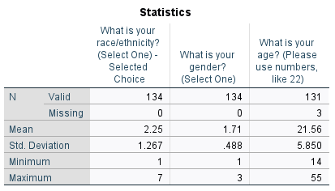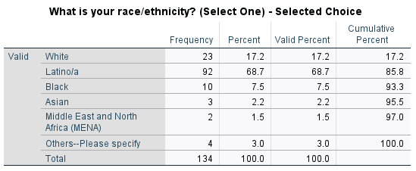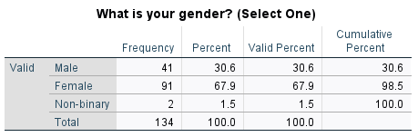
Materials and Procedures
One hundred thirty-four prospective participants were contacted and asked to partake in an online study for research purposes on a potential AI policy proposed for FIU students. Before proceeding, participants gave consent, and a subsequent link to the study was provided through Qualtrics. Before moving on to the survey portion of the study, participants were directed to the first page which detailed the duration, procedure, and potential risks and benefits to be in accordance with the informed consent procedure. Before moving on to the policy in Part A, participants were given instructions to complete the survey as a current FIU student who would be directly impacted by the policy, and to imagine being a current FIU student if they aren’t one already. If the participants wished to continue, they provided their consent once again within the Qualtrics study and then proceeded with the rest of the survey, consisting of four parts: Part A which established the AI policy, Part B and C which measured the participant’s reactivity and conformity, and Part D which collected demographics information.
In study one, there were three levels analyzed for the independent variable of language (high controlling language, low controlling language, and neutral language). Upon further data analysis, the findings indicated that the differences between low controlling language and neutral language was not significant, hence neutral language was dropped and the other two conditions remained for study two. This study replicates study one with extension and adds a second independent variable of agreement, with two levels of high agreement (86%) and low agreement (43%). A blurb in the beginning of the policy (present in all conditions) explained that this policy was used to gage student opinion on implementation of AI policy and provided the percentage of average agreement (either 86% or 43% depending on the condition) of 1000 prior students surveyed. The participant is instructed to read the policy and provide their ratings of the policy as a second sample of polling. This leaves participants to be randomly assigned one of four conditions: (1) High Controlling Language and High Agreement condition, (2) High Controlling Language and Low Agreement condition, (3) Low Controlling Language and High Agreement condition, and (4) Low Controlling Language and Low Agreement condition, with 25% of the sample being allocated to each condition. In this survey, participants were shown the same policy as in study one (with respect to language seen in low or high controlling conditions).
Following Part A, participants completed a survey identical to study one, detailing their perceptions of the policy. First, Part B was be completed which included ten questions that were used to rate the participant’s thoughts and feelings about the proposed policy. Then, Part C was be completed which included four questions used to rate the participant's likelihood of following the proposed AI policy. Both parts B and C measured ratings on an interval Likert scale ranging from 1 (Strongly Disagree) to 7 (Strongly Agree) for all statements. Before each part, participants were reminded to answer the following questions as if they were a current FIU student (if they weren’t already). Only two out of the fourteen statements were analyzed (“I intend to ignore the AI policy” and “AI policy threatens my freedom to choose how I complete my assignments”), whereas the rest were measured. The interaction between manipulated variables, reactance and agreement, were also analyzed for both dependent variables.
Once participants completed parts B and C, participants were directed to the final part of the study: Part D, demographic information. This included seven statements, one through five being standard demographic information, with one through three being identical to study one (gender, age, and race/ethnicity). New statements three through five were added which asked the highest level of education completed (less than high school, high school diploma or GED, associates degree or technical/vocational certificate, some college no degree, four-year college degree, some graduate work no degree, graduate or professional degree, other – explained), and if they were a current FIU student (yes, or no). Questions six through seven included multiple-choice attention check questions which prompted participants to mark the tone they remembered the AI policy using when describing the policy (Using AI is “prohibited”, or “discouraged”) and the ratings of the prior 1000 students provided in the beginning of the study (“86%”, or “43%”) The nominal measure of attention is important to note if the participant paid sufficient attention to the study, and if it had the desired effect (i.e., if participants in the high controlling language and low agreement condition felt and recalled that the policy was controlling, and so forth).
Following completion of the study, participants were thanked for their time and debriefed digitally, noting the theory of psychological reactance and conformity, and explained aspects such as controlling language and agreement. The purpose of the study, procedures, and hypotheses were also elaborated on.
Results Study Two
We ran a chi-square with condition (High Agreement v. Low Agreement) as the independent variable and participant recall of agreement percentage from past participants surveyed from the policy (86% or 43%) as the dependent variable. A manipulation check in previous participant agreement level with the AI policy was significant, χ²(1) = 81.43, p <.001. Most participants who viewed the high agreement condition correctly recalled high agreement (85.5%) while most participants who saw the low agreement condition recalled low agreement (93.1%). Phi showed a large effect. Thus, participants saw our applicant as intended. See Table 6.
Table 6
Crosstabs and Chi Square – Study Two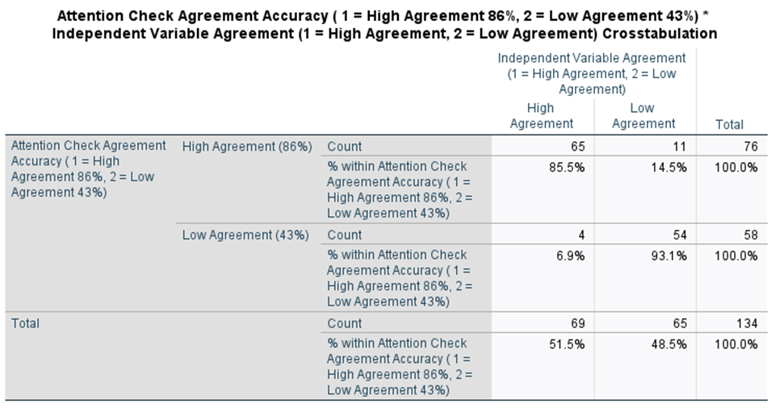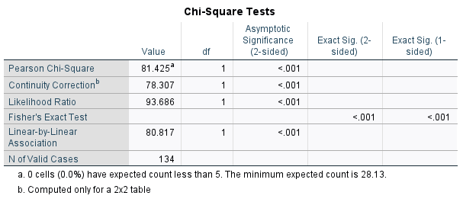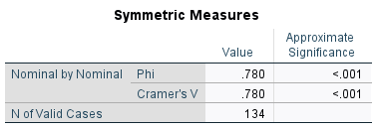
We ran a factorial ANOVA with reactance (High versus Low Controlling) and agreement (High 86% vs. Low 43%) as our independent variables and ratings of intention to ignore the AI policy as our dependent variable. There was a main effect of reactance, F(1, 130) = 14.18, p < 0.001. Those in the high controlling condition (M = 3.85, SD = 1.77) intended to ignore the AI policy more than those in the low controlling condition (M = 2.75, SD = 1.65). There was not a main effect of agreement, F(1, 130) = 0.89, p = 0.35. Those in the high agreement condition (M = 3.17, SD = 1.78) did not differ from those in the low agreement condition (M = 3.42, SD = 1.80) in ratings of intention to ignore AI policy. There was not a significant interaction, F(1, 130) = 0.71, p = 0.40. Thus, there was no difference in intention to ignore AI policy between the high controlling condition and the high agreement condition (M = 3.60, SD = 1.74), the high controlling condition and the low agreement condition (M = 4.13, SD = 1.78), the low controlling condition and the high agreement condition (M = 2.74, SD = 1.75), and the low controlling condition and the low agreement condition (M = 2.76, SD = 1.58). See Table 7.
Table 7
Intention to Ignore AI Policy 2x2 Factorial ANOVA – Study Two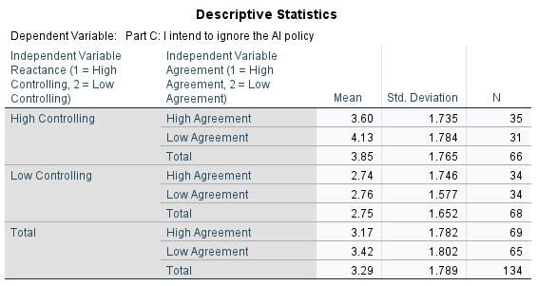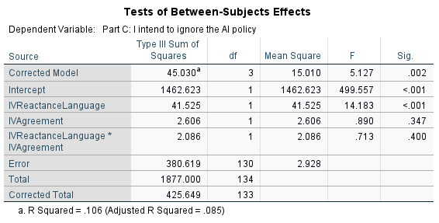
We ran a factorial ANOVA with reactance (High versus Low Controlling) and agreement (High 86% vs. Low 43%) as our independent variables and ratings of the statement “the AI policy threatens my freedom to choose how I complete my assignment” as our dependent variable. There was a main effect of reactance, F(1, 130) = 8.91, p = 0.003. Those in the high controlling condition (M = 3.47, SD = 1.83) felt that the policy threatened their freedom more than those in the low controlling condition (M = 2.66, SD = 1.50). There was not a main effect of agreement, F(1, 130) = 2.31, p = 0.131. Those in high agreement condition (M = 2.87, SD = 1.56) did not differ from those in the low agreement condition (M = 3.26, SD = 1.85) in ratings of the statement policy threatened their freedom. There was a significant interaction, F(1, 130) = 6.04, p = 0.02. The first simple effects test focusing on high agreement was not significant, F(1, 67) = 0.16, p = 0.70. Participants did not differ in their ratings of threats to freedom in the high controlling language policy (M = 2.94 SD = 1.68) than those in the low controlling language policy (M = 2.79, SD = 1.45). The second simple effects test focusing on the low agreement policy was significant, F(1, 63) = 13.35, p <.001. If given a high controlling language policy, participants more strongly agreed that the policy threatened their freedom (M = 4.06, SD = 1.83) than those who received the low controlling language policy (M = 2.53, SD = 1.56). The third simple effects test focusing on high controlling language was significant, F(1, 64) = 6.76, p = 0.012. If given a low agreement policy, participants were more likely to feel that the policy threatened their freedom (M = 4.06, SD= 1.83) than those who received high agreement policy (M = 2.94, SD = 1.68). The final simple effects test focusing on the low controlling policy was not significant, F(1, 66) = 0.52, p =0.47. Participants did not differ in their ratings of threats to freedom when they received a high agreement policy (M = 2.79, SD = 1.45) or a low agreement policy (M = 2.53, SD = 1.56). See Table 8.
Table 8
Threatens Freedom to Choose 2x2 Factorial ANOVA – Study Two
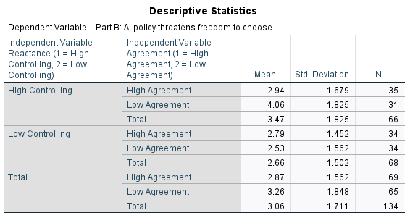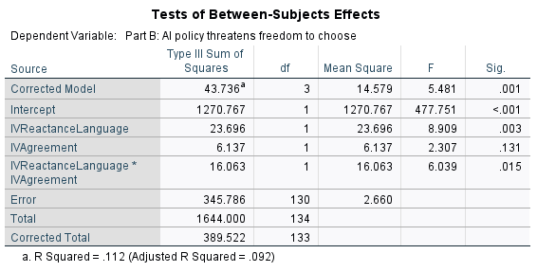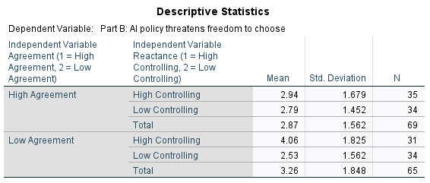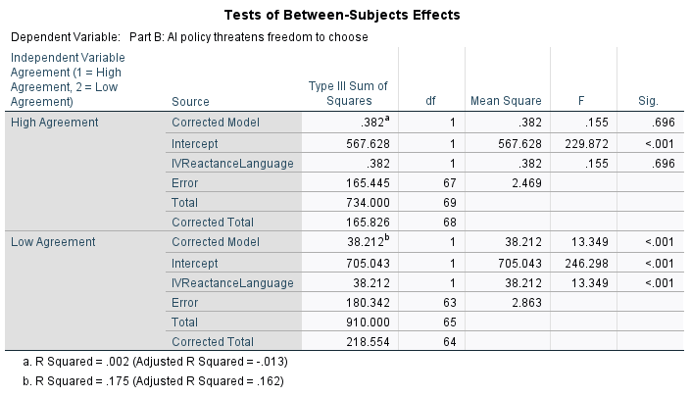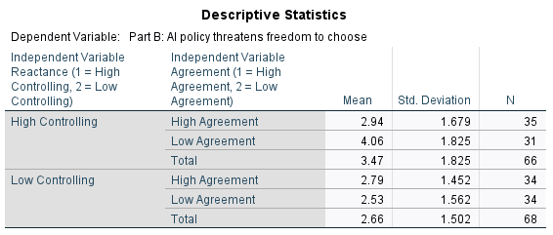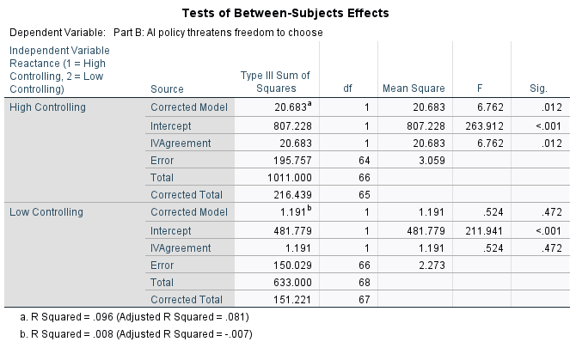
Discussion Study Two
We hypothesized that participants who read an AI policy with high controlling language will more strongly agree that that they “intend to ignore the AI policy” and that the “AI policy threatens freedom to choose how to complete assignments” when compared to participants who read an AI policy with low controlling language. For both DVs, the main effect of reactance was significant as it was present in higher levels in the HC condition than the LC condition, thus supporting the hypothesis. Specific high controlling language induces reactance which may explain this phenomenon; participants perceive this language as a threat to freedom which reduces their intent to comply as a means to regain their freedom.
We also hypothesized that participants who read an AI policy with low agreement will more strongly agree that that they “intend to ignore the AI policy” and that the “AI policy threatens freedom to choose how to complete assignments” when compared to participants who read an AI policy with high agreement. Contrary to what was hypothesized, there was no significant main effect of agreement for both DVs since ratings did not differ between the HA condition and the LA condition. This may be possibly explained by the participant’s own intrinsic agreement/disagreement with the policy outweighing social influence since it is a policy that would directly affect them and has high consequence.
Moreover, we predicted an interaction effect between reactance and agreement where participants will more strongly agree that that they “intend to ignore the AI policy” and that the “AI policy threatens freedom to choose how to complete assignments” with the combination of high controlling language and low agreement conditions compared to the combination of low controlling language and high agreement conditions (with the remaining conditions HC/HA and LC/LA not differing between each other and falling between the other two conditions). Although there was no significant interaction between reactance and agreement for the “intention to ignore AI policy” DV in all conditions (HC/HA, HC/LA, LC/HA, and LC/LA), which did not support the hypothesis, there was a significant interaction between reactance and agreement for the “AI policy threatens freedom to choose how to complete assignments” DV. The condition of high agreement (with HCL and LCL conditions) and the condition of low controlling policy (with HA and LA conditions) did not differ in their ratings regarding threats to freedom. Alternatively, the condition of low agreement policy (with HCL and LCL conditions) and the condition of high controlling language (with HA and LA conditions) was significant. The low agreement policy condition saw a greater interaction effect in the HCL condition than the LCL condition, and the high controlling language condition saw a greater interaction effect in LA condition than HA condition. An interaction was only seen between HCL and LA. In other words, higher levels of reactance were seen in the AI policy with high-controlling language and low agreement, compared to an AI policy with low-controlling language and high agreement, hence, supporting the hypothesis. Certain combinations of the policy may amplify or mitigate participants' reactions based on certain factors. It may be possible that when the perceived risk is low, individuals may rely more on conformity rather than their intrinsic agreement (as seen in “intention to ignore AI policy” DV). This contrasts with the situation observed in the “AI policy threatens freedom to choose” DV, where individuals may prioritize their intrinsic agreement over conformity.
General Discussion
To build upon previous studies, psychological reactance and conformity in the context of AI policy were analyzed in order to gain insight as to how individuals view and respond to regulatory measures in a new world of rapidly evolving technology. In both studies, we hypothesized that participants in the high controlling language condition would experience greater levels of reactance. This prediction was supported in both studies, as participants exposed to high-controlling language in AI policy scenarios demonstrated greater levels of reactance, perceiving the policy as extreme and a threat to freedom in study one, while intending to ignore the policy in study two. Since both studies verified great significance of reactance, it increases the study’s reliability. This aligns with prior literature on PRT, indicating that controlling language can trigger reactance responses with the increase of perceived threat to autonomy (Ma & Miller, 2022; Frey et al., 2021). Be that as it may, reactance may not always translate directly into behavior. It is difficult to say that participant’s intentions to ignore the AI policy were directly influenced by reactance alone, rather than their intrinsic motivation. Future studies should incorporate other forms of measurement and longitudinal designs to determine if reactance is translated to action.
Expanding upon study one, study two investigated conformity by analyzing how agreement levels within AI policy scenarios influence individuals' perceptions and intentions. In study two, we predicted that participants in the low agreement condition would be influenced by conformity thus falling susceptible to group norms regarding AI policy acceptance. Contrary to our hypothesis, agreement levels did not significantly impact reactance levels (as a threat to freedom to choose) and intentions to ignore the AI policy. Despite this, an interaction effect was significant between high controlling language and low agreement for the measurement of policy threatening freedom to choose which partially supported the hypothesis. This interaction effect between language control and agreement levels suggests that intrinsic agreement may outweigh social influence in determining individuals' responses to AI policies, yet certain combinations of agreement alongside reactance can elicit greater aversive responses under the right circumstances. This finding is in line with prior research suggesting that conformity is influenced by multiple factors, including situational contexts, individual differences, influence from others, and the significance of the issue (Song et al., 2012; Pool & Schwegler, 2007).
While this study offered valuable insight, several limitations should still be considered. The population for both studies had a narrow pool of participants. The majority of participants were of college age which may have influenced perception of AI. Others were friends and family of the researchers, which could impact the salience of the issue and impartiality of results on the participants' end. Future studies should study different age cohorts since the younger generation may have greater exposure and familiarity with AI compared to older generations which may skew reactance results. Additionally, the participant pool should be more controlled, possibly limiting it to only college students, to enhance validity and obtain a randomized sample of participants to prevent bias and ensure reliability. Moreover, the majority of participants were Hispanic and female which could introduce cultural and gender-based influences on responses, so a more diverse sample size would be beneficial. All prior factors mentioned would make the study more generalizable by increasing external validity.
Furthermore, the method of measurement could be refined in future studies. Conducting one study face-to-face and another online may have inadvertently introduced demand characteristics, such as social-desirability bias in face-to-face interactions and depersonalization in online settings. The online study might have also limited the pool of potential participants to those who are already familiar and comfortable with technology. Using consistent technology across studies would help mitigate the modality differences and ensure more reliable results. Additionally, while we manipulated language control and agreement levels within AI policy scenarios, the approach to measuring reactance and conformity relied solely on participants' responses. Future studies could benefit from incorporating more direct measures such as longitudinal designs and behavioral observations, as individuals often struggle to accurately assess their own opinions and future performance. Correspondingly, utilizing more immersive and relatable scenarios in the future (regarding AI) could enhance participant involvement and deepen understanding of conformity’s effect in different situations.
The rapid integration of technology and AI across various sectors has outpaced regulatory efforts, raising concerns about ethical and societal implications. This can be seen in the music industry where AI can autonomously generate songs or mimic popular artists' voices to produce new content without their consent. Similarly, in Hollywood, AI has been favored over human writers, leading to contentious issues such as low compensation rates, as evidenced by the SAG-AFTRA strike. The unprecedented growth of self-learning technology has both immense potential and significant risks, particularly in the prospect of interference in individuals' work opportunities or as a positive influence in their daily lives. For this reason, understanding the psychological processes that contribute to the formation of policy is crucial to achieving a safeguard against potential harm and ensuring responsible AI usage. By integrating insights from both reactance and conformity theories, we provide a stronger understanding of how individuals perceive and respond to potential AI policies. Future research could further expand on the interaction between reactance and conformity in diverse contexts and populations, as well as investigate additional factors that may influence these effects.

References
Castrellon, J. J., Zald, D. H., Samanez-Larkin, G. R., & Seaman, K. L. (2024). Adult age-related differences in susceptibility to social conformity pressures in self-control over daily desires. Psychology and Aging, 39(1), 102–112. https://doi.org/10.1037/pag0000790
Frey, T. K., Moore, K., & Dragojević, M. (2021). Syllabus sanctions: Controlling language and fairness as antecedents to students’ psychological reactance and intent to comply. Communication Studies, 72(3), 456–473. https://doi.org/10.1080/10510974.2021.1876130
Ma, H., & Miller, C. H. (2022). “I felt completely turned off by the message”: The effects of controlling language, fear, and disgust appeals on responses to COVID-19 vaccination messages. Journal of Health Communication, 27(6), 427–438. https://doi.org/10.1080/10810730.2022.2119311
Pool, G. J., & Schwegler, A. F. (2007). Differentiating among motives for norm conformity. Basic and Applied Social Psychology, 29(1), 47–60. https://doi.org/10.1080/01973530701330983
Prišuta, N., Ivanec, D., & Podlešek, A. (2023). Social influence in rating music. Psychological Topics, 32(1), 163–178. https://doi.org/10.31820/pt.32.1.9
Quick, B. L., & Kim, D. K. (2009). Examining reactance and reactance restoration with South Korean adolescents: A test of psychological reactance within a collectivist culture. Communication Research, 36(6), 765–782. https://doi.org/10.1177/0093650290346797
Rui, J. R., Chen, J., Wang, L., & Xu, P. (2023). Freedom as right or privilege? Comparing the effect of power distance on psychological reactance between China and the United States. Health Communication, 1–13. https://doi.org/10.1080/10410236.2023.2212138
Song, G., Ma, Q., Fang-Fei, W., & Li, L. (2012). The psychological explanation of conformity. Social Behavior and Personality, 40(8), 1365–1372. https://doi.org/10.2224/sbp.2012.40.8.1365
Toff, B., & Suhay, E. (2018). Partisan conformity, social identity, and the formation of policy preferences. International Journal of Public Opinion Research, 31(2), 349–367. https://doi.org/10.1093/ijpor/edy014
Young-Jones, A., Lévesque, C., Fursa, S., & McCain, J. (2019). Autonomy-supportive language in the syllabus: supporting students from the first day. Teaching in Higher Education, 26(4), 541–556. https://doi.org/10.1080/13562517.2019.1661375

